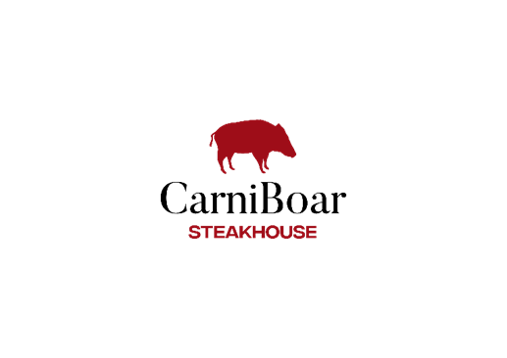
Sunday special SHARING PLATTER
(Based on 2 sharing’s)

Creamed potatoes, maple roasted parsnips & carrots, roast potatoes, braised red cabbage, cauliflower cheese, collard greens, carrot & swede mash, yorkshire pudding & beef dripping sauce

2 meat roast 40
(Select from 2, Ribeye, ½ chicken, mini gammon, Belly pork, Brisket)

3 meat Roast 50
(Select from 3, Ribeye, ½ chicken, mini gammon, Belly pork, Brisket)

Subject to availability

We add a 10% optional service charge to each bill, which goes directly to the staff. This can easily be removed if asked. If you have any dietary requirements, then please ask a member of staff for more information. (gf) denotes a dish is gluten free |* denotes it can be prepared gluten free |(vg) denotes a dish is vegan | (+) denotes the dish can be prepared vegan
Sunday special SHARING PLATTER
(Based on 2 sharing’s)

Creamed potatoes, maple roasted parsnips & carrots, roast potatoes, braised red cabbage, cauliflower cheese, collard greens, carrot & swede mash, Yorkshire pudding & beef dripping sauce

2 meat roast 40
(Select from 2, Ribeye, ½ chicken, mini gammon, Belly pork, Brisket)

3 meat Roast 50
(Select from 3, Ribeye, ½ chicken, mini gammon, Belly pork, Brisket)

Subject to availability

We add a 10% optional service charge to each bill, which goes directly to the staff. This can easily be removed if asked. If you have any dietary requirements, then please ask a member of staff for more information. (gf) denotes a dish is gluten free |* denotes it can be prepared gluten free |(vg) denotes a dish is vegan | (+) denotes the dish can be prepared vegan

