Mains

* **Mini smashed cheeseburger - skinny fries, baked beans (*) 7.50**
* **Chicken burger - skinny fries, baked beans (*) 7.50**
* **Fish fingers - skinny fries, baked beans (*) 7.50**
* **Chicken goujons - skinny fries, baked beans (*) 7.50**
* **Sausages - mash, peas & gravy (*) 7.50**
* **Mac & cheese - garlic bread 7.50**
* **Mini Steak- with fries (*) £7.5**
* **Mini Sunday Lunch- £7.50 (Available Sundays)**

Puddings

|  |
| --- |
| * **ice cream (2 scoops) – strawberry, chocolate, vanilla, honeycomb, salted caramel (gf) 3.50** * **Brownie - vanilla ice cream, chocolate sauce 4.50** * **Belgian waffle - butterscotch sauce, honeycomb ice cream 4.50** * **Oreo sundae - whipped cream, chocolate ice cream, smashed Oreos, caramel sauce, French & italian meringue 4.50**   Drinks   * **Fizzy - pepsi max / diet pepsi / lemonade / tango** * **Juices - apple / orange / pineapple / cranberry** * **J2O - orange & passionfruit / apple & raspberry** * **Squash - orange / blackcurrant** * **Mocktails – mango crush / popstar martini / nojito** |

**Now you’ve ordered your food….. time for the FUN bit………………………………… turn over!!!!**

We Love our Boar!! We don’t have a name though!! What would you call him?...........................................................................

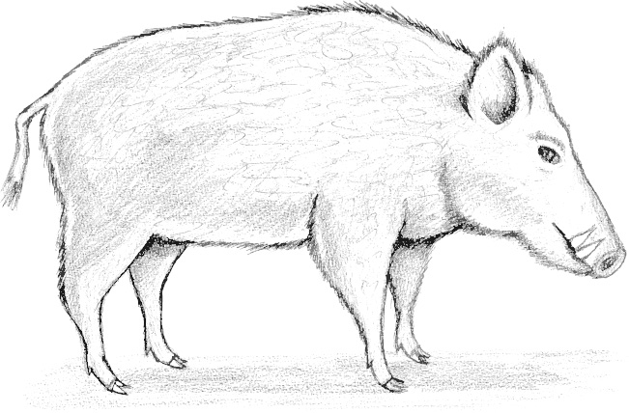Why not colour him in? add some wings, or a hat… you could even paint his toenails!!!

|  |  |  |  |  |  |  |  |  |  |  |  |  |  |
| --- | --- | --- | --- | --- | --- | --- | --- | --- | --- | --- | --- | --- | --- |
| S | T | E | A | K | H | W | N | I | E | G | F | R | Can you find them all? |
| A | A | O | D | I | O | C | H | A | M | Q | I | T | They can be diagonal |
| U | U | E | D | D | L | O | U | R | W | O | P | Y | horizontal or vertical |
| C | S | Y | F | A | T | C | I | A | D | Y | O | U |  |
| T | A | A | A | L | U | K | X | L | A | K | W | O |  |
| J | G | O | T | Y | P | T | Z | K | F | L | O | T | Steak |
| U | E | B | B | H | O | A | C | J | R | E | W | Y | Cocktails |
| I | S | P | O | N | I | I | V | H | E | D | W | H | Fishnchips |
| K | L | P | A | U | U | L | B | G | S | F | I | N | Juice |
| L | K | U | R | J | Z | S | E | E | H | A | D | L | Fatboar |
| J | R | T | Z | M | U | Y | I | R | E | S | S | O | Brownie |
| P | U | F | F | I | J | R | R | T | A | D | A | O | Ice |
| E | F | I | J | K | F | A | J | T | O | F | U | Q | Cream |
| E | E | R | C | L | Q | U | S | V | I | F | C | A | Sausages |
| W | E | X | C | E | J | A | J | C | U | T | E | W | Fresh |
| Q | D | R | T | U | P | L | R | W | L | W | O | E | Fries |
| S | D | Y | U | I | O | D | M | F | K | Z | H | D | Pasta |
| I | D | I | E | Y | I | M | L | P | L | I | M | E | Mooo |
| C | R | H | Y | U | C | R | E | A | M | Z | T | Z | Lime |
| D | R | O | N | I | E | J | K | O | P | Y | U | D | Sauce |
| Q | T | Y | P | L | I | K | Y | U | M | G | O | M | Ham |
| F | I | S | H | N | C | H | I | P | S | O | P | F | **Can you do it in under 5 mins??** |